Exercise Number:3
Date:10/10/2020

Aim:
To write a Python program to remove and print every second number from a list of numbers until the list becomes empty.

Program:
def remove3number(list):
temp=[]
p=1
s=0
for i in range(0,len(list)):
s=(p+s)%len(list)
el=list.pop(s)
temp.append(el)
return temp
n=int(input())
list=[]
for i in range(0,n):
list.append(int(input()))
p=remove3number(list)
print(p)
Link:
http://103.53.53.18/mod/vpl/forms/submissionview.php?id=231&userid=1746

Output:

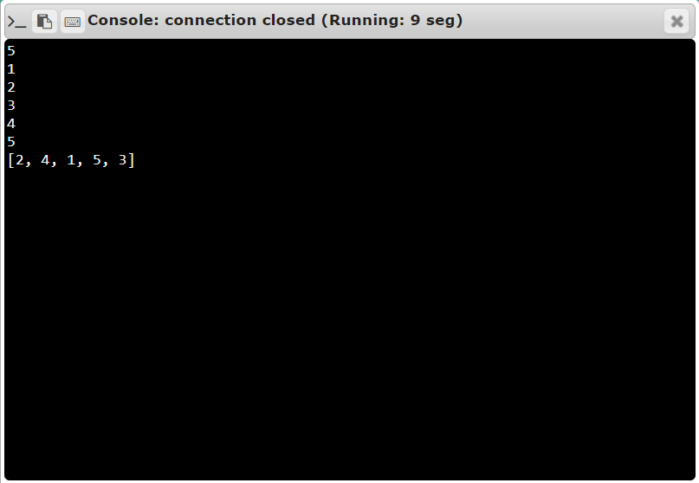
Result: The output of this program is verified

